Statutory vs. Common Laws

Where do laws come from?


During the Middle Ages, laws were created from different sources. Some laws were passed down from tradition and others were decreed by the ruling Monarch (that’s the king/queen). In America today, we know laws no longer come from just the ruling leader of the country. That would seem unacceptable in today’s standards. For the population of the Middle Ages, that was just the way things went back then. During these times, toilets were just seats with holes in them on bridges over rivers (Anyone want to go swimming?). The fact that the king decided to make a new law off the top of his head was the least of people’s worries back then. But if the older sources are no longer making laws, then who is?
Lawmaker
Lawmaker

Over time, Absolute Monarchs, or kings that had absolute power, slowly began to give more rights to the people. In some instances, monarchs were held at sword point to sign documents giving more power to the people. King John did such a terrible job of being Monarch that his barons (wealthy landlords) sieged his castle and made him sign the Magna Carta, which limited some of his powers as King and is one of the first instances of Limited Government. All of these changes created new sources of laws.
Put it all together: Answer the questions using both readings
The period of time from 500-1400 AD was known as the | Middle Ages

During this time period, what were the three main sources of laws?
Tradition
Monarchs
Roman Catholic Church

Which toilet during these times seemed the MOST disgusting to you? (and why)
Varies. But it should be the chamber pot.

Which three events led to changing the sources of laws?
Signing the Magna Carta
Scientific Revolution
Enlightenment

Statutory Laws

One of these sources of laws began to emerge in the Middle Ages; laws passed by the Legislature (the lawmaking branch of the government). The laws they create are known as Statutory Laws. At first, lawmakers were made up of wealthy nobles and advisors for the king. These elite members of society were most trusted to create laws for other citizens in their country. It’s no surprise that many laws made by the wealthy elite members of society focused mainly on the wealthy elite members of society and not the average person. This is even reflected in the two houses of British Parliament (lawmakers); One chamber of Parliament is known as The House of Lords. To participate in this lawmaking body, you had to be a Lord (from a family with ties to the king) or from the Clergy. As the rights of the common man began to improve over time, so did their positions in government.
Creating statutory law
Creating statutory law

Lawmakers in the USA are elected to their positions by the people and make up the Legislative Branch. They are responsible for sponsoring and writing proposed laws, called bills, for the people they represent. Any law that is created by Congress is known as a statute, or Statutory Law.
Put it all together: Answer the questions using both readings
2 lawmaking bodies that make Statutory Laws are | Legislature | Parliament

Which three groups of people used to make up the lawmaking bodies?
Wealthy Nobles
Clergymen
Advisors for the king

Which House of Parliament had the wealthiest people?
House of Lords

What is Congress responsible for (4 things)?
Sponsoring | Discussing
Voting | Writing

Common Laws
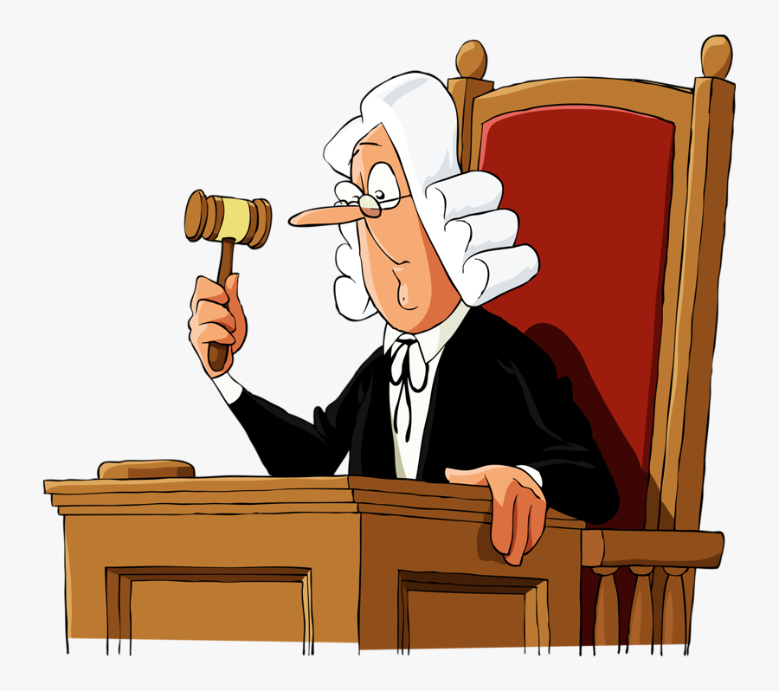
IDuring the Middle Ages, England established Common Laws in addition to Statutory Laws. King Henry II sent royal judges around the English countryside to hear and decide cases. The King told his judges to consider the local customs from similar cases when making their rulings. The judges would make their way back to London and discuss their cases to compare them with other regions of the country. The goal was to create a system of laws ‘common’ to the entire kingdom.
Establishing precedent

Common laws take into account laws not only passed by Parliament/Legislative branch, but also customs and decisions earlier judges reached on similar issues. In this way, judgements wouldn’t be wildly inconsistent in each region of the country. Common laws focus on precedents- previous decisions reached by a judgement based on similar issues. If you commited theft of property over 400 dollars, and received a punishment of 30 hours community service, completion of an anti-shoplifting class, and a fine of 500 dollars, Common law helped shape your punishment. That means other people who have stolen similar amounts of property have also received a similar punishment as you in the past. If someone were to steal the same thing as you in the future, and receives the death penalty or life in prison as the punishment, that would be unfair and against Common Law practices.
Put it all together: Answer the questions using both readings
The King asked his judges to consider | Past decisions | and | Local Customs | when making their rulings

How does common law prevent judgements from being wildly different in each region?
Common law prevents judgements from being different by collecting information from all over the country on how the law is being judged and compiling a ‘common’ decision for each scenario/situation.

How does common law ensure fairness in court decisions?
Common law ensures fairness in court decisions because judges consider what those in the past were punished with. This ensures no one is punished too extremely or not enough.

